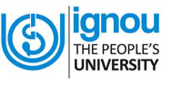 | Indira Gandhi National Open University  Regional Centre Jammu  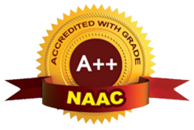  Rajinder Vihar Phase-1, Bantalab, Jammu, J&K-181123  [Website] www.ignou.ac.in  [RC website] www.rcjammu.ignou.ac.in [E-mail] rcjammu@ignou.ac.in

Profile-IGNOU Regional Centre Jammu

S.No. | Description | JAMMU
1. | Number of Study Centres | 31
2. | Programmes offered (number) | 106
3. | Cumulative Number of Students enrolled Since Inception. | 559064
3. | Fresh 2021-22 | July 2021: 16451  Jan 2022: 7433  Total 23884
3. | Re-registration 2021-22 | July 2021: 11034  Jan 2022: 11556  Total 22590
3. | Fresh 2022-23 | July 202: 13615  Jan 2023: 6582  Total 20197
3. | Re-registration 2022-23 | July 2022: 14124  Jan 2023: 8559  Total 22683
4. | Outreach to
4. | SC (%) | 16.8%
4. | ST (%) | 11.5%
4. | OBC (%) | 8.06%
4. | Minority (%) | 9.25%
4. | Women (%) | 49.55%
4. | Transgender (%) | -
4. | PwD (%) | 1.05%
5. | Outreach to Rural (%) | 77%

Detail of RC's jurisdiction: Ten Districts of Jammu Province of Jammu & Kashmir Union Territory.:-

Jammu, Kathua, Samba, Reasi, Doda, Udhampur, Ramban, Kishtwar, Rajouri, Poonch.

Enrolment trends and the target groups who will be benefitted: RC Jammu has shown sustainable growth in enrollment over the years. This RC on an average registers around 40000-45000 learners in a given academic calendar year. The target group of the RC has been rural and tribal areas of the region. Around 77% learners from the rural and tribal areas have enrolled themselves under this RC in the Fresh July 2022 as well as Fresh July 2023 admission cycles.

Year | Session-wise Enrolment |  | Total
Year | January | July | Total
2019 | 16394 | 25031 | 41425
2020 | 20230 | 24438 | 44668
2021 | 22447 | 27485 | 50032
2022 | 1898927739111 | 27739 | 46728
2023 | 15141 | 26386 | 41527

Enrollment Statistics

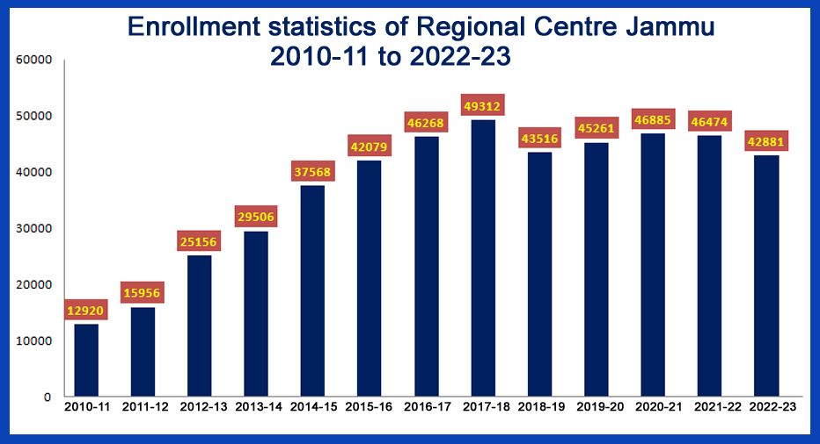

Picture of the newly constructed Regional Centre Jammu Campus

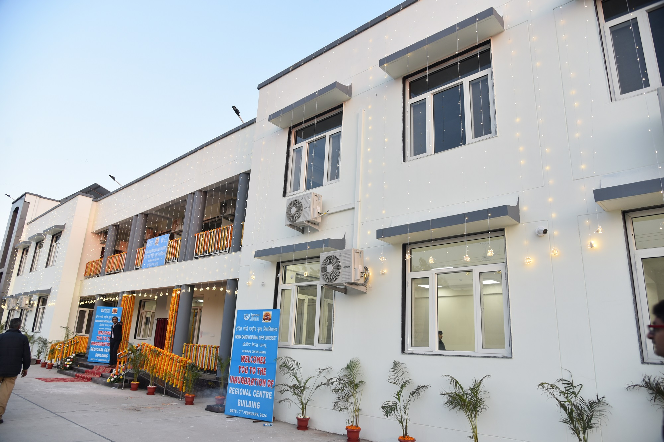

Location of the building: Rajinder Vihar Housing Colony, Phase-I at Bantalab, Jammu (J&K)-181123.

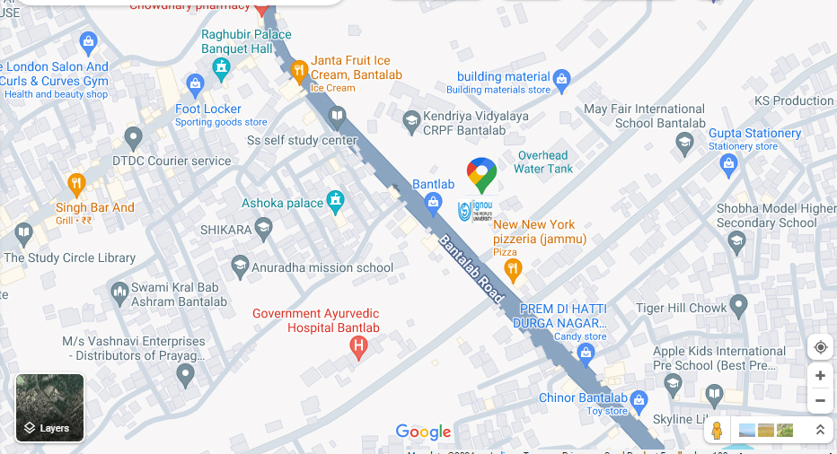

IGNOU Regional Centre Jammu will be celebrating the 37th Convocation function of the University on 20th February, 2024. This would be the 28th Convocation ceremony at the Regional Centre ever since its establishment in the year 1998.

The Regional Centre Jammu started its operations in the 1998 for the entire erstwhile State of J&K on the invitation of the then Government of J&K with around 1000 students and an offering of about 40 Programmes linked to one Learner Support Centre in the University of Jammu.

Today IGNOU is the largest Open and Distance Learning platform available to a huge number of masses in India and across the word as well. IGNOU is widely acknowledged as a leader in the ODL system offering a number of academic, vocational, professional and skill based job-oriented programmes through a wide network of Regional Centres which facilitate a huge network of Learner Support Centres across the country and abroad as well.

IGNOU has been working hard for the past 39 years to accomplish its mission of equality, inclusivity, quality, accessibility and affordability in higher education which is also the mandate for National Education Policy 2020. IGNOU offers a huge range of around 318 programmes at the Masters, Bachelors, Diploma and Certificate level through Open and Distance Learning mode. The University offers around 45 programmes through online mode as well.

To realize the goal of reaching 50% Gross Enrollment Ratio (GER) by 2035 IGNOU has made concerted efforts to introduce academic programmes offered through ODL and Online modes. In 2023, 318 ODL and 45 online programmes were on offer. In light of the National Education Policy (NEP) 2020, the University has implemented Four Year Undergraduate Programme (FYUP) in which the learners would have the freedom to select their desired courses providing curriculum’s interdisciplinary flexibility. Students in various fields such as sciences, computer sciences, psychology, library science, social work, sustainable development, counselling and family therapy, food and nutrition, anthropology, education, health sciences, nursing, information security, and more, are expected to actively participate in hands-on learning experiences to enhance their job prospects.

The University has implemented 39 new academic programmes in the Open and Distance Learning (ODL) format for the January 2023 and July 2023 admission cycles. The programmes offered encompass diverse disciplines such as Jyotish, Urdu, Sanskrit, Drawing and Painting, Entrepreneurship, Information Security, Performing Arts, Development Communication, Smart City Development, Communicative Sanskrit, Solid Waste Treatment Techniques, Diaspora and Migration, Environmental and Occupational Health, Sustainability Science, and Renewable Energy. Subjects of study: Vedic Studies and Yoga. Various programmes are specifically tailored to address a wide range of requirements in various professional domains.

IGNOU has become the First Open University in the Country to have been accredited with the highest A++ Grade by NAAC. The programmes are offered in compliance to NEP 2020 Guidelines.

Today IGNOU Regional Centre Jammu has marked its presence in almost every corner of the Jammu region with a network of 31 Learner Support Centres which include 4 Jail Centres exclusively for Jail inmates. IGNOU caters to needs of the under privileged and down trodden masses of the far flung and remotest corners of region.

After a long wait of more than 26 years, Regional Centre Jammu has now got its own new campus at Rajinder Vihar, Phase-I, Banlatab, Jammu which was recently inaugurated on 7th of February, 2024 by Shri Dharmendra Pradhan, Hon’ble Union Minister of Education, virtually.

Regional Centre Jammu has a huge databank of more than 3700 empanelled Academic Counsellors in different disciplines. These Academic Counsellors are faculty members in conventional higher education system.

The Jammu Regional Centre has consistently shown sustainable growth in enrollment over the years. Regional Centre Jammu has registered more than 75 percent learners from the rural far flung and tribal areas which clearly represents the reach and popularity of IGNOU in far flung remote and tribal areas of the region.

In the 37th Convocation of the University on 20th February, 2024, as many as 3,08,584 learners will be presented with the degree/diploma/certificate at IGNOU New Delhi Headquarters and 39 Regional Centres across the country. Under the Jammu region, as many as 12454 learners have been declared successful and eligible to receive Diplomas and Degree Certificates in the 37th Convocation function at Jammu which includes 5698 learners of Master Degree programmes, 6235 learners of Bachelor Degree programmes, 416 learners of Diploma/Post Graduate Diploma programmes and 105 learners of Certificate/Post Graduate Certificate programmes. Shri Jagdeep Dhankar, Hon’ble Vice President of India will be the Chief Guest on this occasion at the New Delhi HQs. of IGNOU.

Prof. Ashok Aima, Distinguished Chair Professor, School of Management, MIET-Jammu and Former Vice Chancellor, Central University of Jammu, will be the Guest of Honour and deliver Convocation address in the 37th Convocation function of Regional Centre Jammu being organized in the Auditorium of Central Sanskrit University, Shri Ranbir Campus, Kot Bhalwal, Jammu on 20th February, 2024 at 9AM.

As per the details provided by New Delhi HQ. of IGNOU, as many as 310 qualified students have submitted the requisite fee and consent to receive their respective Degree/Diploma certificates in person in the Convocation function at Regional Centre Jammu.
[Dr. Jai Prakash Verma]
Regional Director

